THEME 6. SCATTER DIAGRAM

Also called: scatter plot, X–Y graph
The scatter diagram graphs pairs of numerical data, with one variable on each axis, to look for a relationship between them. If the variables are correlated, the points will fall along a line or curve. The better the correlation, the tighter the points will hug the line.

When to Use a Scatter Diagram
- When you have paired numerical data.
- When your dependent variable may have multiple values for each value of your independent variable.
- When trying to determine whether the two variables are related, such as…
  - When trying to identify potential root causes of problems.
  - After brainstorming causes and effects using a fishbone diagram, to determine objectively whether a particular cause and effect are related.
  - When determining whether two effects that appear to be related both occur with the same cause.
  - When testing for autocorrelation before constructing a control chart.

Additional Scatter Diagram Examples
Below are some examples of situations in which might you use a scatter diagram:
- Variable A is the temperature of a reaction after 15 minutes. Variable B measures the color of the product. You suspect higher temperature makes the product darker. Plot temperature and color on a scatter diagram.
- Variable A is the number of employees trained on new software, and variable B is the number of calls to the computer help line. You suspect that more training reduces the number of calls. Plot number of people trained versus number of calls.
- To test for autocorrelation of a measurement being monitored on a control chart, plot this pair of variables: Variable A is the measurement at a given time. Variable B is the same measurement, but at the previous time. If the scatter diagram shows correlation, do another diagram where variable B is the measurement two times previously. Keep increasing the separation between the two times until the scatter diagram shows no correlation.

Scatter (X Y) charts are typically used for showing and comparing numeric values, like scientific, statistical, and engineering data.
A Scatter Chart has two value axes −
- Horizontal (x) value axis
- Vertical (y) value axis
It combines x and y values into single data points and shows them in irregular intervals, or clusters.
Consider using a Scatter chart when −
- You want to change the scale of the horizontal axis.
- You want to make that axis a logarithmic scale.
- Values for horizontal axis are not evenly spaced.
- There are many data points on the horizontal axis.
- You want to adjust the independent axis scales of a scatter chart to reveal more information about the data that includes pairs or grouped sets of values.
- You want to show similarities between large sets of data instead of the differences between the data points.
- You want to compare many data points regardless of the time.
  - The more data that you include in a Scatter chart, the better the comparisons.
Follow the steps given below to insert a Scatter chart in your worksheet.
Step 1 − Arrange the data in columns or rows on the worksheet.
Step 2 − Place the x values in one row or column, and then enter the corresponding y values in the adjacent rows or columns.
Step 3 − Select the data.
Step 4 − On the INSERT tab, in the Charts group, click the Scatter chart icon on the Ribbon.
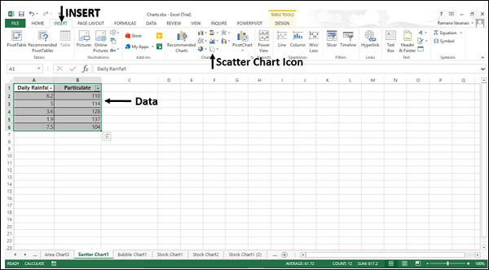

You will see the different types of available Scatter charts.
A Scatter chart has the following sub-types −
- Scatter
- Scatter with Smooth Lines and Markers
- Scatter with Smooth Lines
- Scatter with Straight Lines and Markers
- Scatter with Straight Lines

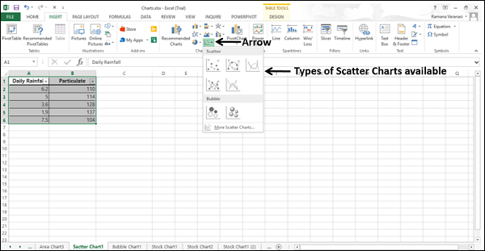

Step 5 − Point your mouse on each of the icons. A preview of that chart type will be shown on the worksheet.
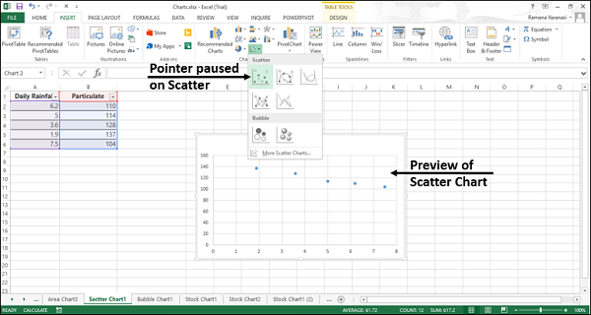

Step 6 − Double-click the chart type that suits your data.
In this chapter, you will understand when each of the Scatter chart is useful.

Scatter Chart
Scatter charts are useful to compare at least two sets of values or pairs of data. Scatter charts show relationships between sets of values.

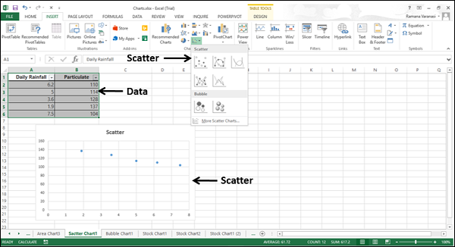

Use Scatter charts when the data represents separate measurements.

Types of Scatter Charts
The following section explains the different options available to display a Scatter chart.

Scatter with smooth lines and markers and scatter with smooth lines.
Scatter with Smooth Lines and Markers and Scatter with Smooth Lines display a smooth curve that connects the data points. Scatter with Smooth Lines and Markers and Scatter with Smooth Lines are useful to compare at least two sets of values or pairs of data.
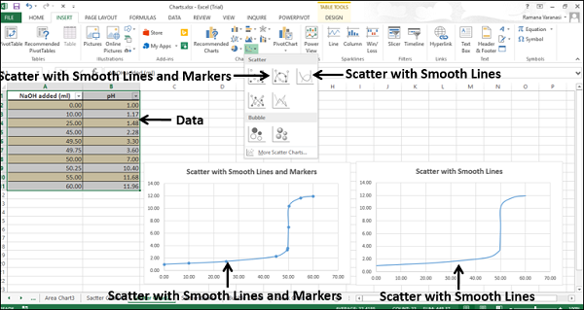

Use Scatter with Smooth Lines and Markers and Scatter with Smooth Lines charts when the data represents a set of x, y pairs based on a formula.
- Use Scatter with Smooth Lines and Markers when there are a few data points.
- Use Scatter with Smooth Lines when there are many data points.

Scatter with Straight Lines and Markers and Scatter with Straight Lines
Scatter with Straight Lines and Markers and Scatter with Straight Lines connects the data points with straight lines. Scatter with Straight Lines and Markers and Scatter with Straight Lines are useful to compare at least two sets of values or pairs of data.

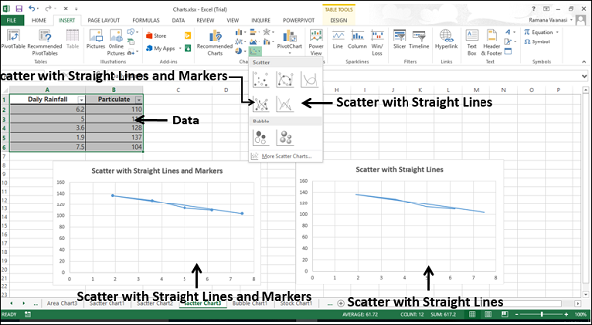

Use Scatter with Straight Lines and Markers and Scatter with Straight Lines charts when the data represents separate measurements.
- Use Scatter with Straight Lines and Markers when there are a few data points.
- Use Scatter with Straight Lines when there are many data points.

